Image | 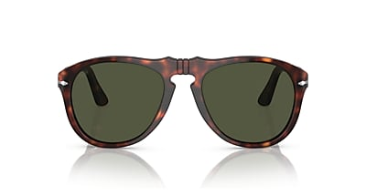
Brand | OLIVER PEOPLES
Model Name | 649 - Original
Price | RS 2799
PRODUCT DETAILS

